Embargo until maY 5, 2022, 12:00 am cet/ 6:00 AM EST

Bluesound Announces the HUB Network Accessory
Add “multi-room streaming” to the list of things your legacy audio sources can do

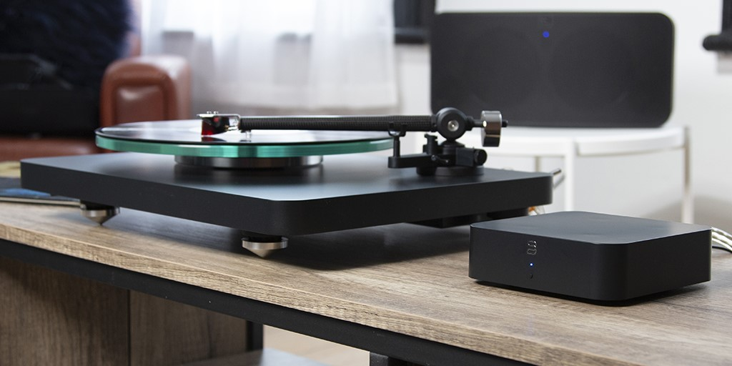
“Bluesound HUB with turntable and PULSE 2i connected”
ISE 2022, BARCELONA, SPAIN May 5, 2022 – Bluesound, makers of the award-winning hi-res wireless multi-room line of audio players, announces the HUB, a game-changing network accessory that connects to a variety of analog and digital audio sources, bringing them into the Bluesound ecosystem for multi-room streaming. Retail availability of the HUB is expected in mid-June and is priced at USD $319 / EUR €349 / GBP £309 / CAD $419.

ANY SOURCE, IN ANY ROOM
Streaming audio is more flexible than ever with the HUB. Easily add a Bluesound HUB to any non-BluOS enabled audio source and transmit music to one or many Bluesound players around the home. Audio sources like a turntable or CD player instantly become network-connected and are new sources from which your Bluesound system can play music. The HUB unlocks the problem of geography in letting users stream vinyl wirelessly for the first time.

PLENTY OF CONNECTIVITY OPTIONS
From TVs to CD players, turntables to the latest gadgets, a host of inputs on the back panel: HDMI eARC, Coaxial, Digital Optical, Stereo Analog, and a moving magnet Phono stage supports the vast majority of music devices. Each HUB can manage one analog and one digital source simultaneously, and up to four (4) HUBs can be added to a single network.

EASY SETUP. EASY CONTROL.
Equipped with BluOS, the HUB makes adding audio sources simple using the BluOS Controller app setup wizard. A few taps on the familiar BluOS app controls a whole multi-room system from a smartphone, tablet or computer.

MINIMAL WIRES. NO MESS. NO HASSLE.
Simplicity is guaranteed with the HUB. With a 1U rack height, and 1/3rd rack width, external USB-C connected power supply, the HUB can easily be placed on shelves, behind TVs, or mounted with four different orientation options using its two keyhole mounting slots.

THE BEST OF BOTH WORLDS.
Streaming music fans who also love vinyl will be especially appreciative of the HUB's built-in audiophile-grade MM phono stage preamp that brings audio from your turntable to any Bluesound player for whole-home turntable streaming. The HUB acts like a networked low noise, wide-bandwidth phono pre-amp, delivering spectacular audio quality for vinyl enjoyment in any or every room of a home at hi-fidelity.

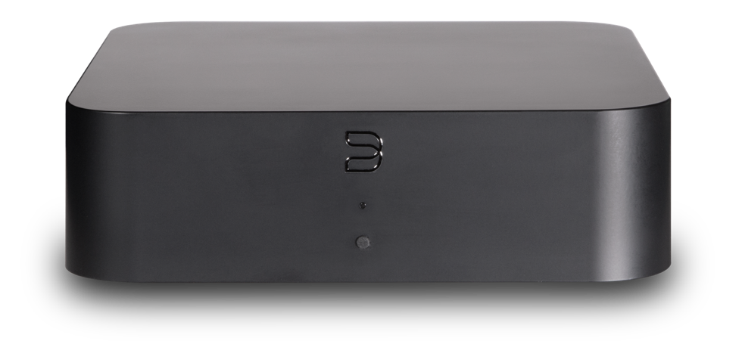
“Bluesound HUB from the front”
Key Highlights of the Bluesound HUB:
- Network Audio Source-sharing with BluOS™
- Low-noise MM Phono Stage
- Stereo Analog Line Input
- HDMI eARC with CEC
- Optical and Coaxial Digital Inputs
- ARM® CORTEX™ A53 Processor
- Dual-band Wi-Fi + Gigabit Ethernet
- Powered by USB-C Power Adaptor
- 1U Rack Height, 1/3 Rack Width
- Four-way Keyhole Mounting Slots
- Front Panel Function Button
- Black Finish

About bluesound
An alliance of audiophiles. We are the designers, engineers and individuals who have spent our lives in the music industry. Our founders helped pioneer HiFi in the 70s – innovation and the pursuit of perfection in audio runs deep in our collective DNA. Bluesound’s sole mission is to create innovative wireless audio products and technologies that allow for the most true-to-live performance music reproduction possible, utilizing the most advanced, state-of-the-art digital technology.

Contacts

Corporate Contact
June Ip
Marketing, Bluesound
media@bluesound.com

US Media Relations
Jeff Touzeau (OLEX Communications – US/Canada)
+1 914-602-2913
jeff@olexcommunications.us

UK Media Relations
Steve Dalton (OLEX Communications – UK)
+44 (0) 7748-117-864
steve@olexcommunications.co.uk

Links
Website: https://bluesound.com
Images: https://brandlibrary.lenbrook.com/portals/bluesound
Facebook: https://facebook.com/bluesound.hifi
Twitter: https://twitter.com/bluesoundhifi
Instagram: https://instagram.com/bluesoundhifi

# # #

